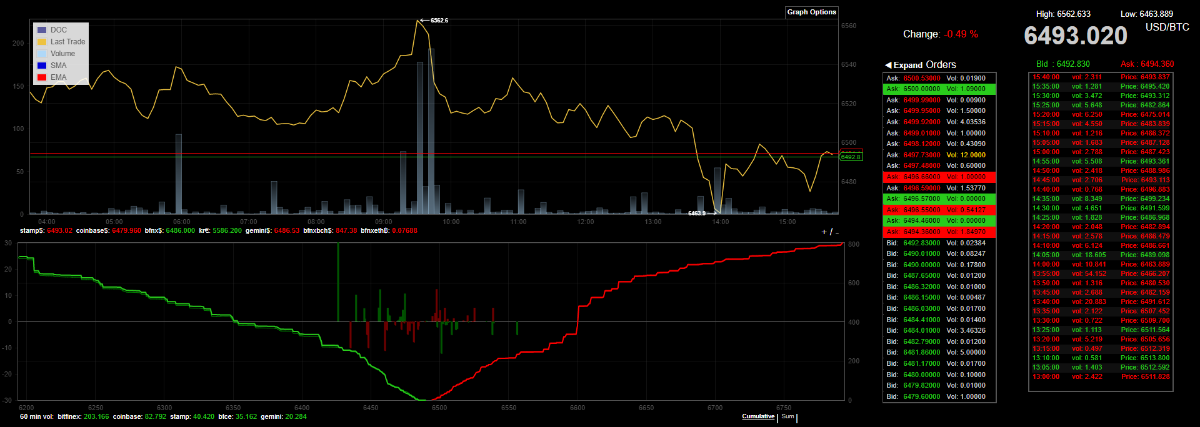**Trading Rules and Regulations**

* **Example of a trading ticker for BTCUSD**

This image is split up into 4 different windows, that come together to make a comprehensive view model for day trading on its basic terms.

1. 2. 3.

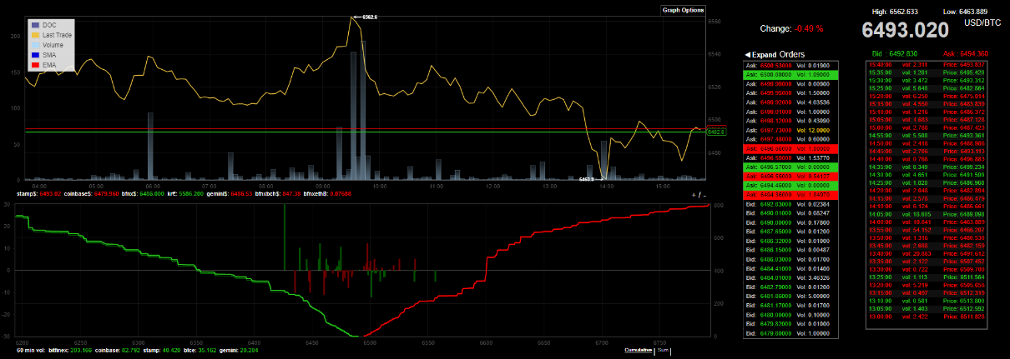

4. 5.

1. Price Ticker chart
2. Buy and Sell log (open bids)
3. Reference for chart 1 Price Ticker, this is the current price of the market.
4. This is the order window, it shows the amount of people willing to buy at different price ranges, the gap in the middle of the green and red, is called the market gap.
5. This is the up to date chart of all the transactions that have gone through the market and blockchain.

* **Defined Rules**

All types of trading execution.

* + **BUY**

This is where you buy an amount of stock towards the price, shown in section 3.

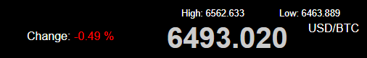

For example, if you were to buy 1 BTC, you will pay $6493.020 to acquire the stock.

* + **SELL**

The same process of selling the stock is like the buy execution, it is always best to sell higher than the price you buy.

* + **HLD**

Holding the stock is the process of holding through a time based on parameters put in place by the trading marketplace used.

* + **EXT**

Like sell, the Exit is where you completely dissolve your assets within the market place to gain as much as you can to gain profit. Commonly known is Panic Exit.